**Lesson02 Azure Storage Account Lab**

**Notes: -**

**1-on azure portal > Azure storage account**

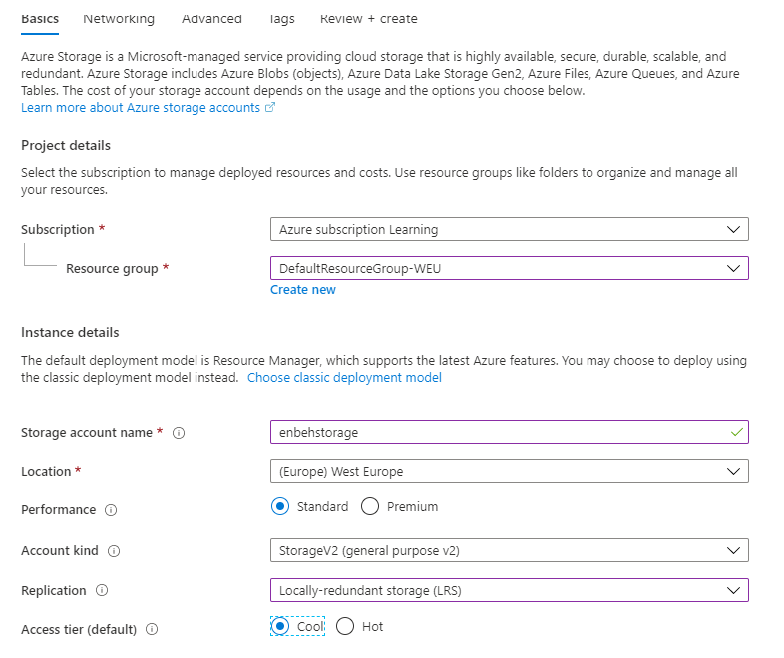

**2-on Network tab we select all public IP address**

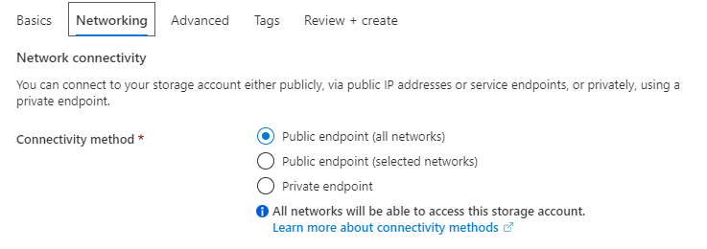

**3-on Advance tab we select the following option**

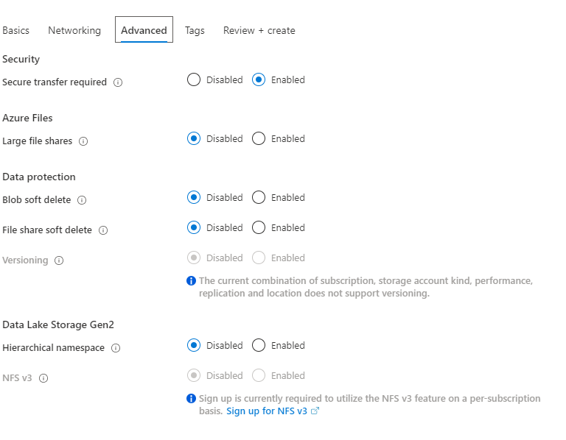

**4-you see in the Azure storage account it contains the following servcies**

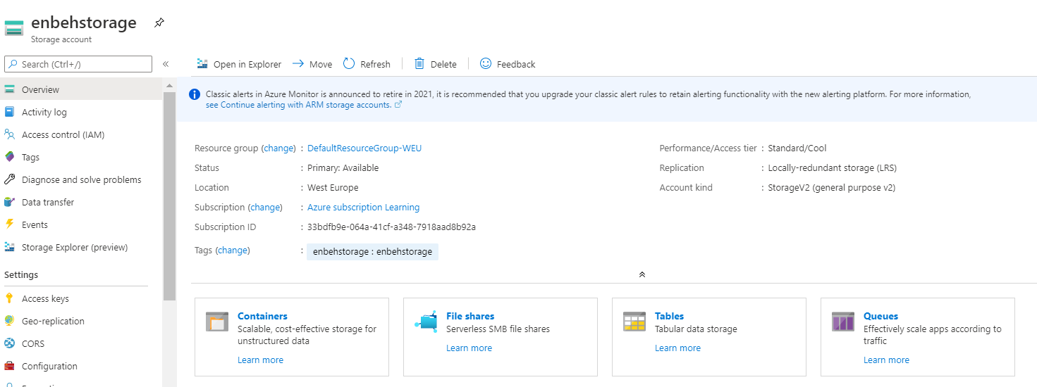

**5-we add container with 3 options**

**Private (no anonmous access): which means it accessable only with provide authentication**

**Blob (anonomous access): which means it accessable for anonmous for blob only**

**Container(anonomous access): which means it accessable for anonmous for blob and container only**

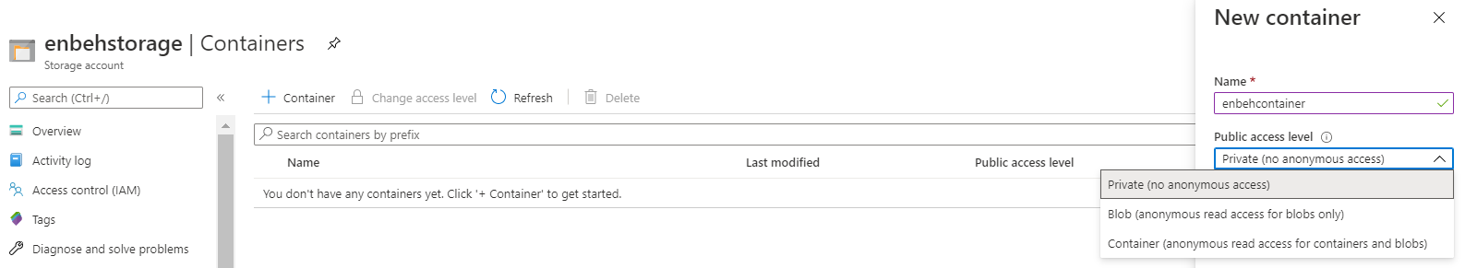

**6-we upload the document to the container and in properities**

[**https://enbehstorage.blob.core.windows.net/enbehcontainer/sample.csv**](https://enbehstorage.blob.core.windows.net/enbehcontainer/sample.csv)

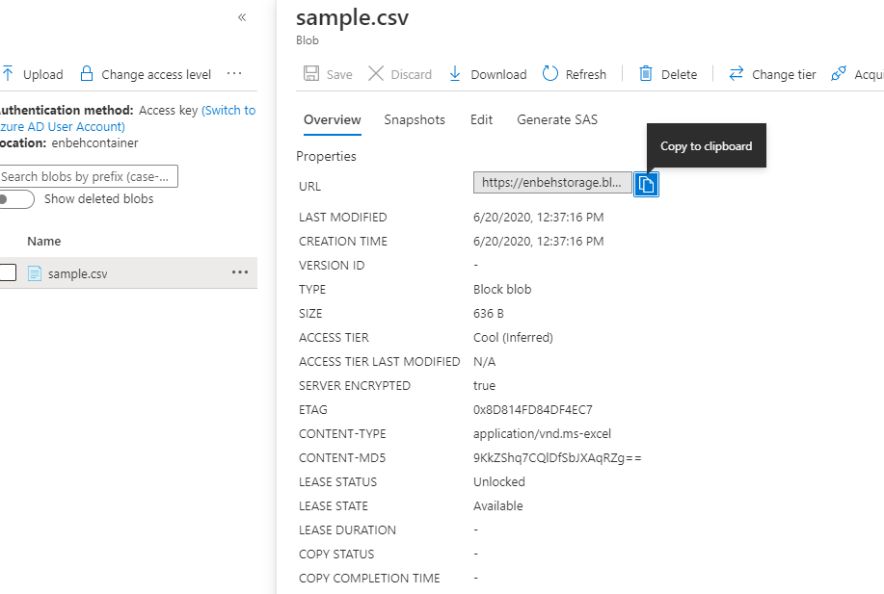

**Azure Storage Explorer**

**Notes:-**

**1-you have 2 version of Azure Storage explorer , one for azure portal and another for desktop app**

**2-for azure storage explorer after login through click connect you see that you can browse to the blob as below**

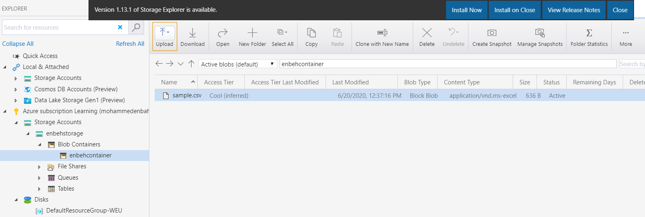

**Azure Storage Access Key**

**Notes:-**

**1-each azure resource has access key in order to access this resources only not all resources via Azure credential account**

**2-on azure portal > azure storage account > access key**

**(we have primary and secondary keys , becouse if you want to generate new key in primary key you can change the connection in web app in storage account key to secondary key and then generate primary key)**

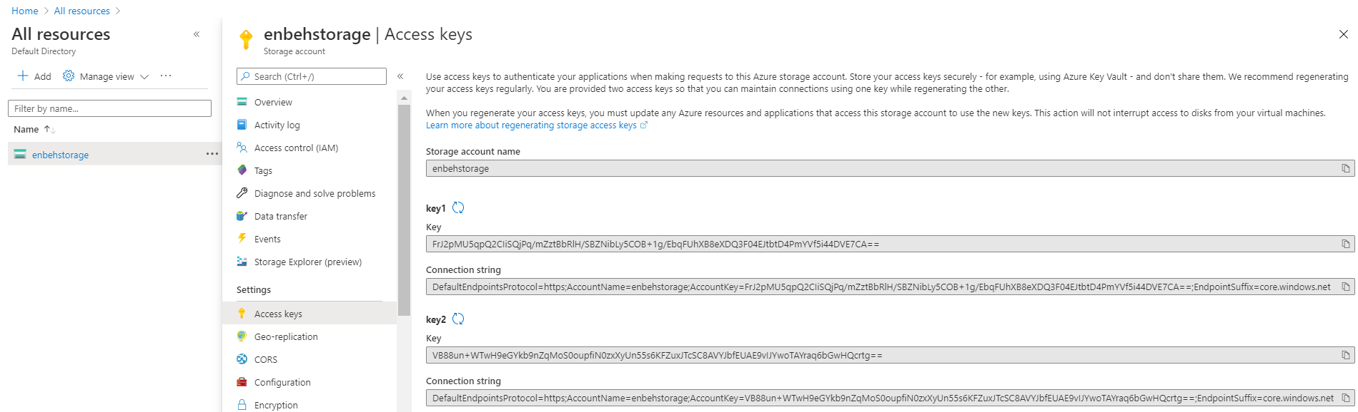

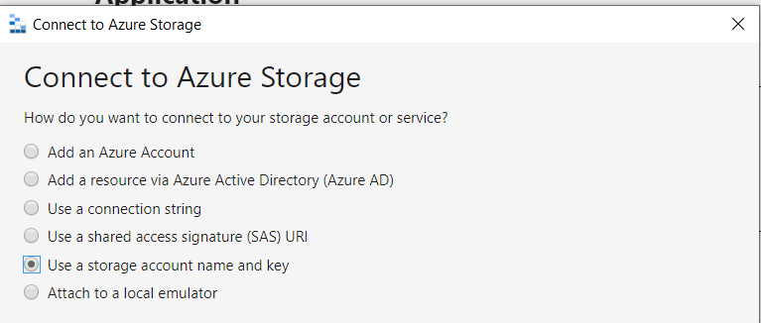

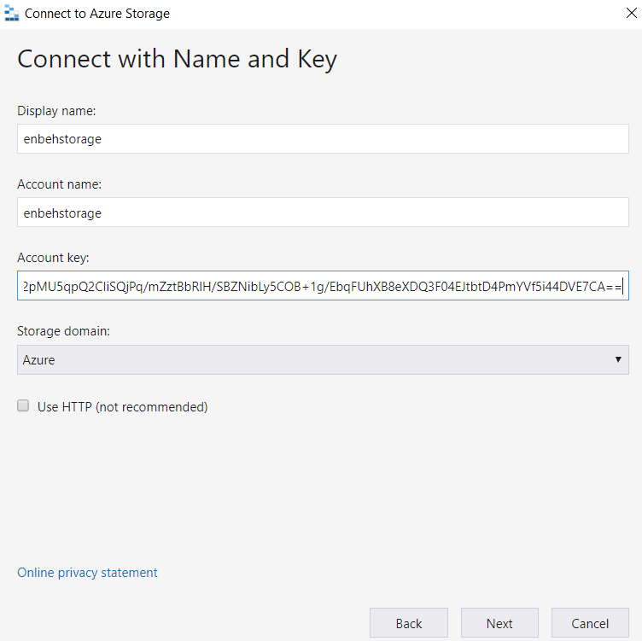

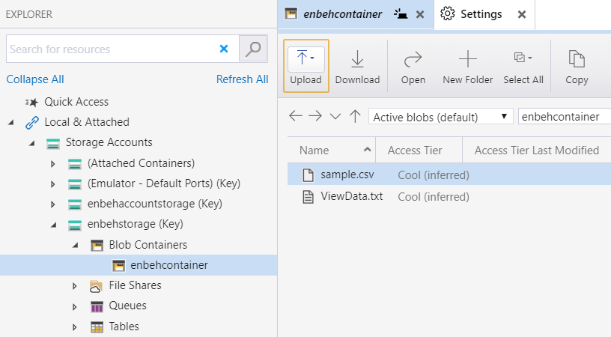

**(we see that the storage account is accessed only via the access key)**